**Task 1:**

* Used .cpp instead of .c to eliminate errors with #include <iostream>

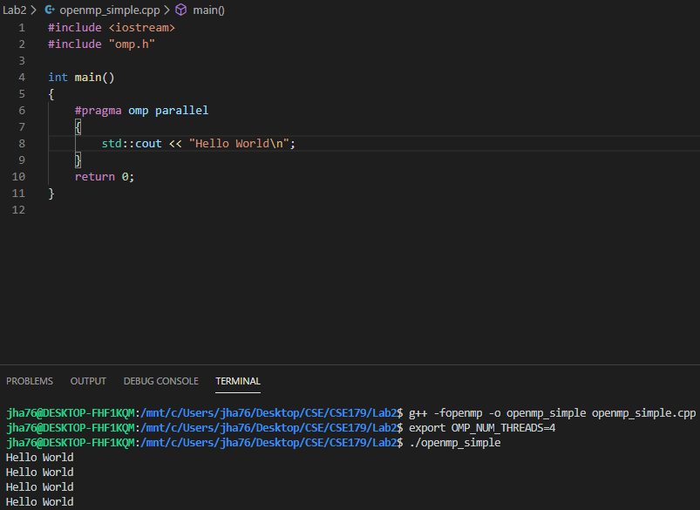

**Task 2:**

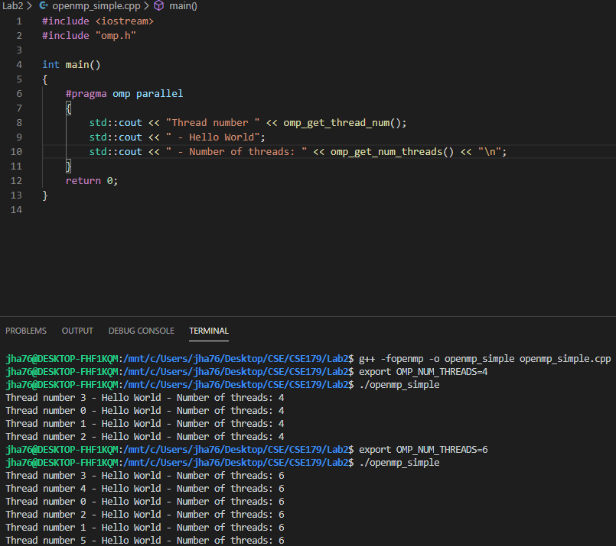

**Task 3.1:**

* My machine has 4 cores.

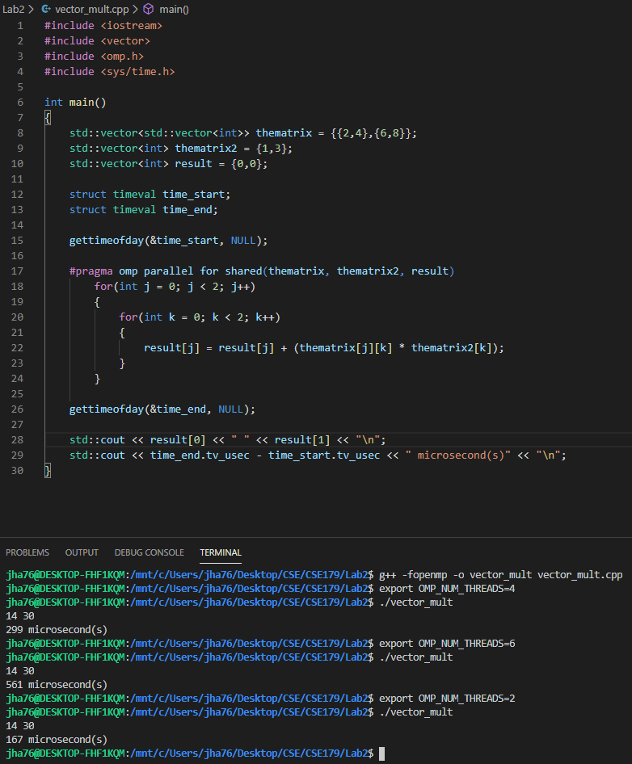

**Task 3.2:**

* The dynamic scheduling was significantly faster than the static scheduling.

